**iLearnCentral: A CLOUD-BASED LEARNING CENTER**

**PLATFORM WITH MOBILE TECHNOLOGY**

A Research/Capstone Proposal

Presented to the Faculty of the

College of Computer Studies, University of Cebu

In Partial Fulfillment of the Requirements

for the degree Bachelor of Science in Information Technology

By

Jephunneh C. Mabini

Rhea Shane M. Chiong

Cristian G. Paragoso

Engr. Edsel C. Paray

Adviser

October 2019

1. **ACKNOWLEDGMENT**

The completion of this study would not have been possible without the presence of the following:

First and foremost, we offer our warm gratitude to our Adviser, Engr. Edsel C. Paray, for sharing his knowledge and guidance in writing our manuscript, for being patient in checking our papers, and for giving suggestions and inspiration for the study’s completion.

To our dear parents, we offer our warm gratitude for the prayers, love, concern, and financial support.

To those who are not mentioned but, in one way or another, have helped us in this study, the product of this manuscript would not be possible without all of them.

Above all, the Almighty Father, the source of infinite wisdom, strength, and goodness. To God be the glory!

**The Researchers**

Jephunneh C. Mabini

Rhea Shane M. Chiong

Cristian G. Paragoso

**DEDICATION**

This project is lovingly dedicated to our respective parents, who have been our constant source of inspiration. They have given us the drive and discipline to tackle a task with enthusiasm and determination. Without their love and support, this project would not have been possible.

To our advisers and professors who genuinely helped us to finish this work,

And above all,

To our beloved God Almighty who never surrendered to shed us His love, grace and wisdom to accomplish this study that, somehow in the very near future, may contribute to help those who will use and appreciate it.

**TABLE OF CONTENTS**

**Page**

ACKNOWLEDGMENT ..................................................................................... ii

DEDICATION .................................................................................................. iii

TABLE OF CONTENTS ..................................................................................... iv

LIST OF TABLES .................................................................................................. vi

LIST OF FIGURES .................................................................................................. vii

CHAPTER I: INTRODUCTION

Rationale of the Study ..................................................................................... 1

Objective of the Study ..................................................................................... 2

Scope and Limitations ..................................................................................... 2

Significance of the Study ........................................................................ 3

Flow of the Study ..................................................................................... 4

Definition of Terms ..................................................................................... 5

CHAPTER II: REVIEW OF RELATED LITERATURE AND STUDIES

Related Literatures ..................................................................................... 6

Related Studies ..................................................................................... 9

Comparative Matrix ........................................................................ 10

CHAPTER III: RESEARCH METHODOLOGY

Software Engineering Methodology ........................................................... 12

Planning/Conception-Initiation Phase ........................................................... 14

Business Model Canvas ........................................................... 15

Program Workflow ......................................................................... 16

Validation Board ......................................................................... 19

Gantt Chart ...................................................................................... 19

Functional Decomposition Diagram ............................................... 21

Analysis-Design Phase ............................................................................ 22

Use Case Diagram ......................................................................... 22

Storyboard ...................................................................................... 23

User Interface Diagram ................................................................... 24

Database Design ......................................................................... 33

Entity-Relationship Diagram ............................................... 42

Data Dictionary ............................................................... 43

Network Design

Network Model ......................................................................... 51

Network Topology ......................................................................... 51

Development/Construction/Build Phase .................................................... 52

Technology Stack Diagram ............................................................ 52

Software Specification ....................................................... 54

Program Specification ................................................................... 55

REFERENCES ................................................................................................... 57

CURRICULUM VITAE ...................................................................................... 59

APPENDICES

A – Working Title Form *.........................................................................*  62

B – Consultation Log Form *.........................................................................*  63

C – Censor’s Certificate *.........................................................................*  64

**LIST OF TABLES**

Table No. Table Name Page

1 Comparative Matrix 10

2 Business Model Canvas 15

3 Validation Board 19

4 Gantt Chart 20

5 User Document 34

6 Learning Center Document 34

7 Educator Document 35

8 Resume Document 36

9 Student Document 37

10 Job Vacancy Document 38

11 Job Application Document 38

12 Course Document 39

13 Enrolment Document 39

14 Payment Document 39

15 Classes Session Document 40

16 Schedule Request Document 40

17 Lesson Plan Document 41

18 Student Record Document 41

19 Database Data Dictionary 43

20 Software List of Modules 55

**LIST OF FIGURES**

Figure No. Figure Name Page

1 Flow of the Study 4

2 Agile Development Methodology 12

3 User Activity Program Workflow 16

4 Hiring Module Program Workflow 17

5 Enrolment Module Program Workflow 17

6 Scheduling Module Program Workflow 18

7 Teaching Assistance Module Program Workflow 18

8 Functional Decomposition Diagram 21

9 Use Case Diagram 22

10 iLearnCentral Storyboard 23

11 Login Page 24

12 Account Type Selection Page 25

13 Sign up Page 25

14 Feature Subscription Page 26

15 Learning Center Profile Page 27

16 Job Posting Page 27

17 Applicants List Page 28

18 Potential Hire Search Page 28

19 Class Management Page 29

20 Educator’s Profile Page 29

21 Job Search Page 30

22 Learning Center Search Page 30

23 Activity Management Page 31

24 Student/Parent Profile Page 31

25 Class Browsing Page 32

26 Enrolment Page 32

27 Payment Scheme Page 33

28 Entity Relationship Diagram 42

29 Network Model 51

30 Network Topology 51

31 Technology Stack Diagram 52

**CHAPTER I**

**INTRODUCTION**

In this era, mobile phone has become fashionable to the public because it is very handy. With the availability of mobile phones, multiple issues have been solved and the bulk of the information is kept online. Initially, when mobile phones first came out, they were only useful for communicating; now they are of multiple usages. Moreover, mobile phones have become the colossal point of attention for individuals and businesses alike, courtesy of the various incredible features and opportunities that they offer (Chatterjee, 2014).

One of the markets or businesses needing to take advantage of mobile solutions is the learning centers. Due to the high turnabout of educators in these centers, the total process takes a lot of time. iLearnCentral helps solve this predicament. It is a mobile application (app) that helps ease the whole experience of learning centers from hiring and profiling of educators to scheduling and enrolment.

**Rationale of the Study**

Insufficient use of Information Technology (IT) is one of the significant reasons that slowed the growth of small and medium-sized enterprises (SMEs) in Asia (Yoshino, 2016). However, outsourcing IT services for SMEs is now a trend for business solutions. Outsourcing IT services can help SMEs by having lower cost, focus on core operations, and IT resources similar to the large establishment (Gluck, n.d.).

Most learning centers are SMEs and would gain an advantage if they would utilize outsourcing of IT. The core operations of learning centers involve manual procedures, and automation by IT can ease the processes. Having the ability to do work conveniently and efficiently by using IT gives the learning center a competitive edge.

It is vital for learning centers to select the best and most qualified educators for their students because they play an important role in building a child’s success in their first years of school. Educators do more than facilitate arts and crafts projects throughout the day. They provide structure and help children grow in their reading and writing skills, teach science and help children understand themselves (Hudson, 2017).

There is a multitude of reasons why educators in the Philippines are quitting their jobs. The attrition rate has steadily increased and according to Ingersoll and Smith (2003), educators' attrition rate has serious consequence in the workplace and students. Although attrition rate is inevitable, learning centers need to hire new educators swiftly without affecting the children’s progress. The faster and easier the process, the better the service.

The researchers use these problems as the basis to create a project that addresses these issues. The researchers are taking advantage of the growth of mobile technology and mobile computing and create the app iLearnCentral. iLearnCentral helps learning centers lessen the administrative burdens and offer an alternative solution for the attrition rate of educators.

**Objective of the Study**

The study aims to develop a cloud-based learning center platform with mobile technology for administrative staff, educators, parents, and students.

To achieve this aim, the specific objectives are:

1. to gather data on the issues encountered by small and medium learning centers;
2. to determine the mechanism for a recommendation system; and
3. to define a notification scheme

**Scope and Limitations**

The development of the mobile and web app of this project study focuses on learning centers and educators within the Philippines. Features of the app are pre-defined for only the common problems across different types of learning centers. The app has three different intelligences available. The app compares the job-seeking educators' profile and details on every job hiring position and suggests the qualified potential hire to the learning centers depending on the pre-set requirements and qualifications of the job hiring position. On the other hand, job-seeking educators get a list of potential job career vacancy recommendations through the app. They can also search manually for institutions, hirings, or job vacancies they want to employ.

Another intelligent feature of the app is the scheduling and optimizing of classes and activity schedules for the learning centers and employed educators.

Lastly, the suggests classes to students and parents basing from their interests and recent searches. The app also has an enrolment management system to help students and parents process enrolment online. The mobile app is designed to operate on a system with an Android version of 5.0 and above and with an internet connection, while the web app is designed to run on Mozilla Firefox, Google Chrome, Microsoft Edge, and Safari browsers.

Unlike company-specific software that is developed to manage their specific needs, iLearnCentral cannot provide learning center-specific features for different types of learning centers. The app cannot help with the hiring of other staff members of learning centers as well, and the functionalities of the mobile app are limited offline.

**Significance of the Study**

The implementation of the system changes the methods and processes that the learning centers and educators are accustomed to and the outcome of the study is beneficial to the following:

**Learning Centers.** They can have an automated system for the common operational processes andthe hiring process of educators is simpler.

**Educators**. They can have a new platform to search for jobs easily. For educators that are already connected with a learning center, they can effortlessly manage their work schedules.

**Parents.** They are able to pay online for their children’s tuition fees, and monitor their children’s school status online.

**Students**. They get the best educator available to help them learn.

**Researchers.** In order to increase the personal knowledge of problem solving and improving their coordination, teamwork and programming skills.

**Future Researchers.** The ideas presented may be used as reference data in conducting new researches. The outcome of the study is beneficial to them as a cross-reference. This study may be one of the bases where a new theory in learning arises.

**Flow of the Study**

Flow of the study shows the inputs and the selection of the processes to be included on the study.

- data on the issues encountered by small and medium learning centers

- mechanism for recommendation system

- notification scheme

- Develop a mobile and web application that cover most of the basic processes of learning centers; hiring, profiling, scheduling and enrolment.

An Agile method that consist of the following phases:

* Requirements Phase
* Plan
* Design Phase
* Development Phase
* Market Release
* Track and Monitor

A Cloud-Based Learning Center Platform with Mobile Technology

**Input**

**Process**

**Output**

Figure 1: **Flow of the Study**

Figure 1 shows the flow of the study. The flow is divided into three parts. Firstly, an input is the requirement needed for the application. Secondly, process is the development of the application. Finally, an output is produced out of the input and process.

The inputs are gathering of information about the issues encountered by learning centers and determining a solution.

The process of the study implements the use of a Software Development Life Cycle methodology, which is the Agile Model. It is composed of 5 phases which include Requirement Phase, Design Phase, Development Phase, Market Release, Track and Monitor Phase.

The output of the study is a mobile and web application that would automate learning centers’ processes and assist educators entitled as "iLearnCentral:A Cloud-Based Learning Center Platform with Mobile Technology".

**Definition of Terms**

The following definitions have terms with meanings in the context of usage in the study. Some of the terms operate only to this study by providing more clarity.

**Class.** Periodic or sporadic meetings of enrolled students and educators to have lessons.

**Class Session.** A single instance of a class with a specific schedule.

**Cloud-Based Platform**. A software that provides services or resources via the internet from a provider’s server.

**Course.** The term for the study of a subject or program offered by learning centers.

**Educators**. They are the teaching staff of the learning center and the people seeking for a teaching job.

**Issues encountered by small and medium learning centers**. These are the problems encountered by the learning center’s operations, the educator’s class management and job seeking, and other problems regarding the parents and students.

**Learning Centers**. Are the SMEs that provides learning services. It could be academic, language, music and arts, etc.

**CHAPTER II**

**REVIEW OF RELATED LITERATURE AND STUDIES**

The literature and studies cited in this chapter tackle the different concepts, understanding, and ideas, generalizations or conclusions and different developments related to study from the past up to the present which serve as the researchers’ guide in developing the project. Those that were also included in this chapter help in familiarizing information that are relevant and similar to the present study.

**Related Literature**

In the Philippines, case study by the United Nations Educational, Scientific and Cultural Organization (UNESCO) shows that an increasing number of school-age Filipinos are out of school. A huge percentage of Filipino children and youth aged 6 to 17 years are not attending school. In 2003, there were a total of 5.18 million out-of-school youth (1.84 million out-of-school children aged 6 to 11 years old, and 3.94 million young people aged 12 to 15) in the country according to the Department of Education (DepEd). In fact, the government estimates that “one in six school-age children in the country is being deprived of education and the number is rising steadily. These numbers have been backed up by a recent Australian Council for Educational Research (ACER) report that highlights the importance of preschool education in the Philippines. The first report of the study, released in May 2016, examined the results of the first of four assessment rounds, which measured the cognitive, social and emotional, and oral language skills of children at the commencement of their first year of school.

The report revealed that students who attended a preschool program performed better across all three domains than those who did not. Accordingly, even in general terms, without collecting and analyzing data on the duration or type of preschool program attended, it appears that attending preschool makes a positive difference within the sample. This supports current interventions and the government’s policy related to investing in early years education.

All these reports show that there is a need of updating and innovating Philippine Learning Center processes as it is vital to the growth and foundation of children. Learning Centers can turn to iLearnCentral to achieve this in a lesser amount of time.

There have been a few books published that pinpoint the significance of educators’ qualification in early childhood education. Sheridan et al. (2009) stated in her book “Professional Development in Early Childhood Programs: Process Issues and Research Needs” that the knowledge, skills, and practices of early childhood educators are important factors in determining how much a young child learns and how prepared that child is for entry into school. Early childhood educators are being asked to have deeper understandings of child development and early education issues; to provide richer educational experiences for all children, including those who are vulnerable and disadvantaged; to engage children of varying abilities and backgrounds; to connect with a diverse array of families; and to do so with greater demands for accountability and, in some cases, fewer resources, than ever before. The importance of understanding the qualities of early childhood educators that contribute to optimal child learning and they are to meet certain educational qualifications and receive professional development to enhance their abilities to support young children's learning. Indeed, the professional development of practicing early childhood educators is considered critical to the quality of experiences afforded to children (Martinez-Beck & Zaslow, 2006).

In the face of increased attention to early childhood professional development in the practice and policy communities, there is a concomitant need for empirical efforts to examine what works for whom, within which contexts, and at what cost (Welch-Ross et al., 2006). Research on early childhood professional development must go beyond basic questions that address caregiver characteristics and their associations with attributes of knowledge, skill, or practice. Rather, establishing a scientific endeavor of early childhood professional development requires building a body of theories and evidence about not only its forms but also its and proximal and distal outcomes. The early childhood field is at a place where professional development practice and craft knowledge require a larger and firmer platform of theoretical and empirical expertise in order to guide planning and implementation of the ambitious kinds of school and child care reforms that are demanded in the current era of services expansion and accountability. Indeed, the field is acquiring a body of findings of the effects of various forms, levels, and organizations of professional development on early childhood educators' knowledge bases and skillsets. However, we need to know more about the dynamic and transactional teaching and learning processes underlying these effects as they function in real-world early childhood settings. For example, we need findings documenting personal theories of change, supportive relationships among participants, and practitioner acceptance/resistance to change. We are even farther behind in building a solid body of empirical information on the indirect but essential influence of professional development on child and family outcomes. The number of children going to preschool and the number of licensed educators has proportionally increased. This gives Learning Centers the liberty of selecting the best available educator basing on their underlying professional development – skills, behaviors, and qualifications.

Additionally, some studies have focused on the efficiency and simplification of the hiring process of employees in bigger companies. The foundation of a high-impact workforce relies on the quality employees, but successful teams cannot be built by antiquated recruiting processes. Talent acquisition professionals are constantly in search of better ways to hire as the demand for talented individuals goes up and pressures on recruiting teams simmer. More than half of talent acquisition leaders say the hardest part of recruitment is identifying the right candidates from a large applicant pool and, unfortunately, that's because many of them are doing so by hand. Companies are looking for more efficient ways to modernize and streamline recruiting efforts. As the hiring process has evolved from newspaper ads to job boards to social recruiting, the next wave of this industry is recruiting automation. Just as salespeople and marketers have benefited from software-enabled automation in recent years, recruiters are increasingly turning to automated mechanisms for hiring the best talent, and the industry is responding accordingly.

Buckley et al. (2004) did some study on the advancement of human resource systems. Presently, these systems are being modified so they can be administered using various forms of computer technology. These technological advances are being driven primarily by strong demands from human resource professionals for enhancements in speed, effectiveness, and cost containment. This case study presents results obtained by an educational publisher from the use of an automated recruiting and screening system. The system allowed for recruiting and the automated administration of professionally developed, job-related questions aimed at deciphering whether an applicant meets the job requirements. The analyses showed conservative savings due to reduced employee turnover, reduced staffing costs, and increased hiring-process efficiencies. The current system coupled with the addition of planned enhancements should increase future hiring efficiency, employee quality, and resulting financial savings.

In May 2018, Reija Oksanen, a faculty member of the University of Tampere, also did a study on the transformation and impact of the use of technology in recruiting practices. The use of technology in recruiting practices is constantly becoming more and more routine amongst organizations. Recruiting as a whole has experienced a major change with new technologies providing quick, effective and cost-efficient ways of finding potential employees. Among these new technologies are big data and Artificial Intelligence (AI). Organizations have been collecting massive amounts of data, and now they are able to derive real value from big data and AI. The research data was collected during the spring of 2018 by interviewing weight recruitment professionals who work among recruitment on a daily basis. Data was studied with qualitative methods by analyzing, coding and identifying themes. As the aim of this study was to widen knowledge about the phenomenon of new technology-based recruitment methods the findings of this study appeared broad and diverse, highlighting the novelty of the phenomenon as opinions of the interviewees varied greatly. Three phases where AI can be of short-lived recruitment process were identified: practical organizing, pre-screening applications, and candidate communication. The benefits and disadvantages of AI in recruitment aroused much discussion and opinions among the interviewees. Numerous opportunities and risks were identified when utilizing new technologies in recruiting. Among other things, accelerating the recruitment process, automation of routine tasks and increasing objectivity were seen as opportunities. The risk of discrimination, data distortion, and invasion of privacy were considered as risks, among others.

**Related Studies**

In July 2018, three students of the University of San Carlos (USC) – Patrick Dave Woogue, Cris Lawrence Adrian Militante, and Gabriel Andrew Pineda – won the grand prize for their online tutorial system at the 14th Smart Wireless Engineering Education Program (SWEEP) Innovation and Excellence Awards for their mobile application Eryl. The application leverages on a mobile platform that allows users to act as student-tutors to those having difficulty with their lessons, thus stimulating collaborative learning within the school. It is a mobile online tutorial system that enables students to join online classes or organize one and it also let them select from a teacher pool and negotiate for a schedule and fee.

OrangeApps, a school management application, has been officially released in 2014 by then 19-year old Gian Javelona. It has since become a huge technology company that builds products that focuses on solving problems in education. Schools of every size use the platform to manage their entire operations from admission, payments, grading, scheduling and a whole lot​ more giving them time to focus more on providing better education. The app comes with multiple features for teachers, students, admins and parents. However, it is designed for large schools and universities.

Schoology was designed by three Washington University students - Jeremy Reid, Ryan wang and Alex Trinidad and has been released since August 2009. It is a cloud-based platform which was originally developed for sharing notes. Today, Schoology provides teachers the tools needed to manage and oversee an online classroom activity for K-12 and higher education institutions.

iEduCentre has focused on the comfort of business owners and administrators for schools and tuition centers. Before the days of the digital revolution, these organizations are saddled with bundles of administrative burdens, endless paperwork and shelves crammed with files. In 2011, Aquarius Soft launched iEduCentre and had since benefited more than hundred over clients in Singapore. After refining the system along the way through rounds of consultations with our clients, we are proud to introduce a total of more than 40 modules, each inter-facing well with one another to create a highly comprehensive, user-friendly and stable system for all our customers.

SpellWizards is an engaging educational program designed specifically to help children learn spelling, while having fun along the way. It has been designed for children aged 4-11 in order to improve their spelling, and enhance their computer knowledge and typing skills. Accessible online as a web app, SpellWizards is an effective support tool which can be used by schools, teachers and parents looking to encourage and engage children to learn through play, with the added benefit of being able to track their progress online.

**Comparative Matrix**

The comparative matrix shows the different studies that are related to the proposal. It shows its differences and is used by the proponents as basis to create and innovate the features of iLearnCentral.

Table 1

COMPARATIVE MATRIX

|  |  |  |  |
| --- | --- | --- | --- |
| **Related Studies** | **Features** | **Limitations** | **Platform Details** |
| Name: Eryl  URL: None  Year: July 2018 | - allows users to become students and tutors  - allows to negotiate on a teacher pool | - not fully released | - None |
| Name:OrangeApps  URL:<https://orangeapps.ph/>  Year:2014  Proponents:Gian Javelona | - admin, reacher, student and parents monitoring and management system | -intended for huge schools and universities | - Web, Android, iOS |
| Name: Schoology  URL: <https://www.schoology.com/>  Year: 2009  Proponents: | - for K-12 school and higher education institutions  - automated grading system  - calendars and messaging | - educator-centric app | - Web, Android, iOS |
| Name: iEduCentre  URL: <https://www.ieducentre.com/>  Year: 2011 | - CRM & scheduling  - attendance tracking, fee automation  - student, parent and portals  human resource & payroll | - only available in the US | - Web |
| Name: SpellWizards  URL: <https://spellwizards.co.uk/>  Year: Unknown | - spelling assistant for children aged 4 to 11 | - only for learning to spell | - Web |

**CHAPTER III**

**RESEARCH METHODOLOGY**

Each section discusses the approach to be used for the analysis and other technical specifications to help reinforce the proposal. It also includes diagrams, designs features techniques, and materials for implementing "iLearnCentral: A Cloud-Based Learning Center Platform with Mobile Technology" to fulfill the study's goals requirement.

**Software Engineering Methodology**

iLearnCentral's development study uses the agile approach as the project framework for software engineering. Agile software development defines an approach to software development under which requirements and ideas progress through the collaborative effort of cross-functional self-organizing teams.

One of the benefits of the agile approach that suits this study is collaboration and open interactions with designers, advisers, and collaborators based on their feedback and any changes that occur throughout the development. It promotes flexible planning, structural growth, first conveyance, ongoing transition, and facilitates rapid and adaptable response to change.

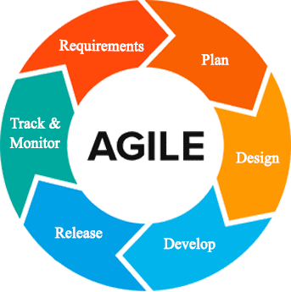

Figure 2: **Agile Development Methodology**

Figure 2 shows the representation of the framework lifecycle in an agile development methodology. The agile process requires less preparation, and the activities split into small increments. The agile process is for short-term projects with a team effort that meets the life cycle of software development (Sharma, 2012). By using customer feedback to agree on ideas, iteratively improves software This approach provides opportunities for assessing the path throughout the development lifecycle This performs by generic workflows, such as sprints or cycles to the end of which teams deliver a material increment that is potentially transmittable. This approach focuses on the replication of abbreviated work cycles and the functional yields of the product.

The developers do the following phases of the Agile Methodology:

**Requirement Analysis.** Defines the requirements for the iteration based on the product backlog, sprint backlog, customer and stakeholder feedback.

The gathered system features are from research conducted and interviews with industry experts in the related fields. The User Interfase (UI) designer and the programmer define the code specifications needed to fulfill the requirements of the project. The technical writer then takes note of changes and checks the document with all team members present. The database designer verifies if the features are compatible with the materials. The project manager reports the improvements made by the team to the team's adviser.

Initially, the team members make the primary manuscript and background researches on learning centers, educators, and job-seekers to lay out the things to do. In every iteration, the team members assigned to work on the obstacles analyze the issues and come up with a possible solution. They consult on resolutions with the other members. At the end of each day, the team members report on their progress.

**Plan Phase.** Phase of preparation involves creating a set of plans that helped guide the team through the phases of project implementation and closure. The plans produced during this process help developers manage time, cost, performance, change, risk, and issues to ensure the project is delivered on time and within budget by the developers.

The team determines schedules, preparations, and plans of actions to handle changes during the iteration. In every sprint cycle, the organizations made are directed towards the fulfillment of its intentions. Itemized priorities and time constraints are the focus of budget allocation by the project manager. The team establishes communication routes for questions and issues that may arise.

**Design Phase.** The specifications evaluated and defined by the designers are used in the design phase to make design choices using various diagrams. The UI designer assigned creates the user interface. The programmer and database designer must describe the device element interface mechanism. The project manager monitors the progress of the members' tasks. From the selected sprint backlog, the team determines which designs to tackle from the manuscript. There is a parallel development of mobile and web applications.

**Development Phase.** This step requires testing usability and reliability for all aspects of the product. The software testing checks if it meets all the specifications set out in the evaluation of requirements and if it handles the information correctly.

The developers check the software, analyze it, and identify the issues and update or modify it beyond the steps or requirements that were set up. Until deployment, all parts of the operation underwent a continuum of individual evaluation through different testing methods to ensure its efficacy and efficiency.

**Release.** Before releasing it to the market, developers carried out several activities to test the application. It allows the system to work within each operation of the deployment phase with tolerable performance and specific processes. Using the guidance given in the deployment document, developers then installed the application in the server environment.

**Track and Monitor.** This phase happens after the program is sent out to the customers/clients in this process. Developers maintain tracking, monitoring, and providing IT support services to include system and software updates and enhancements if appropriate. Feedback gathered from monitoring generates a list of improvements and bug fixes for the next iteration.

Another sprint cycle happens at the end of the previous. A sprint review with all members determines the set of activities for the next iteration. It includes adjustments from leftover unfinished tasks, additional features requested, and feedback from monitoring.

**Planning/Conception-Initiation Phase**

The planning phase discusses the high-level decisions on why a project is valuable and what the requirements are. It helps the researchers keep track of assigned tasks, meeting deadlines, the progress of each requirement, and the budget for project work plans.

**Business Model Canvas**

The Business Model Canvas is a visual representation, commonly used by strategic managers, of existing and emerging business models.

Table 2

BUSINESS MODEL CANVAS

|  |  |  |  |  |  |
| --- | --- | --- | --- | --- | --- |
| **Key Partners** | **Key Activities** | **Value Proposition** | | **Relationships** | **Customer Segment** |
| -Learning centers  -Educators currently teaching in learning centers  -Job seeking educators | -Design and develop an intelligent school management software geared towards the needs of learning centers, educators, students | - System can be used by any type of learning center  - System could automate basic operations of administration with integrated artificial intelligence  - System has additionalsupport to the educators and students | | - Customer service hotlines  - User Feedback  - Email | - Learning center administration  - Educators in learning centers  - Students in learning centers  - Educators seeking employment |
| **Key Resources** | **Channels** |
| - Web domain and host  - Developers  - UI/UX designers  - Researchers | - On-location Visits  - Company Website  - Social Media Marketing  - Word of mouth |
| **Cost Structures** | | | **Revenue Streams** | | |
| - Customer acquisition costs  - Research and Development  - Marketing and Advertising  - Hosting, Operations and Maintenance | | | - Subsciption based on feature packages  - Ad Revenue from free or trial users | | |

Table 2 illustrates the system’s Business Model Canvas. The Business Model Canvas is essential in building a flourishing business market. It gives concrete ideas to the researchers about the target market of the project and the cost of developing it. The Value Proposition shows the importance it gives to the public. Channels are a way for the group to interact simultaneously with customers and investors to sell the program. Customer relationships ensure that the entities involved are supporting our business relationship. Revenue streams demonstrates how we can earn revenue from the services provided.

**Program Workflow**

Defining, managing, automating and optimizing business processes is a software workflow. Progressions of measures (tasks, events, interactions) involving a cycle of work, involving two or more individuals, and generating or adding value to the activities of the organization.

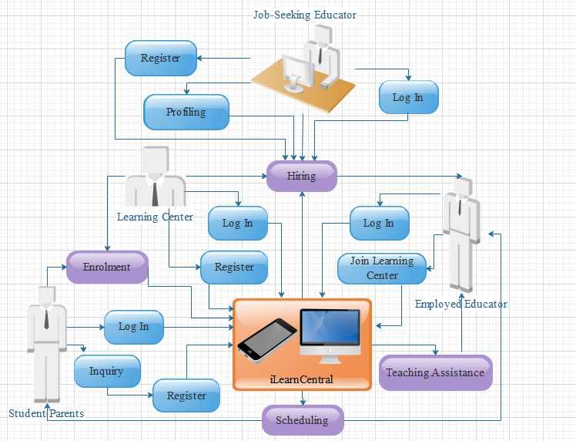

Figure 3: **User Activity Program Workflow**

Figure 3 shows the program workflow for general user activities. The administrative account creation and authentication starts with the registration of learning centers to the system. Job seekers register for an account to build their profile resume. The hiring module involves the learning center and job-seeking educator which could produce an employed educator. Only learning center and employed educator accounts can log in to most of the functionalities of iLearnCentral. Interested students/parents can inquire by creating a free account and browse through services offered by learning centers. Enrolment would involve input from both learning center and the student/parent. The scheduling is processed by iLearnCentral to produce calendars and notification to the employed educator and student/parent.

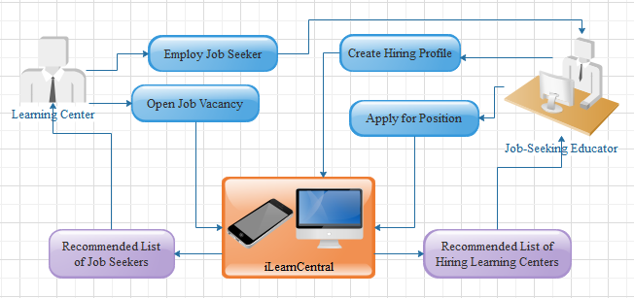

Figure 4: **Hiring Module Program Workflow**

Figure 4 details the hiring module from Figure 3. Job-seeking educators build their hiring profile or resume. After which the system processes their qualifications and determine a list of hiring learning centers from open job vacancies on which they apply for. They can also browse through other job vacancies available. On the other hand, learning centers receive recommended list of job-seeking profiles which fit their requirements.

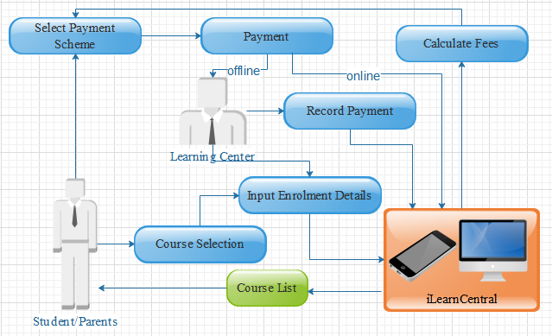

Figure 5: **Enrolment Module Program Workflow**

Figure 5 shows the program workflow for the enrolment module. The student or parent sees a list of courses from the system provided by the chosen learning center. With the selected course/s, they can process enrolment by providing the required information. The system calculates fees needed with the student/parent choosing methods of payment. Offline payment goes directly to the learning center, who would then record the transaction. Paying online is an option using various methods of online payments.

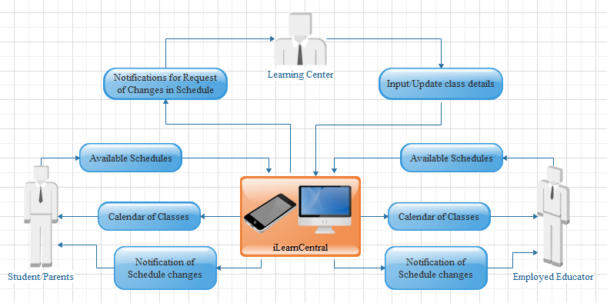

Figure 6: **Scheduling Module Program Workflow**

Figure 6 shows the workflow for the scheduling module. The administrative staff would input class details for scheduling. The students and educators have time available when they can have a class. Schedules depend on matches with classes and educator’s open loads. There should be a consideration for the classrooms available and the learning center’s open business hours. Any changes to the schedule automatically adjusts schedules and notify all persons involved.

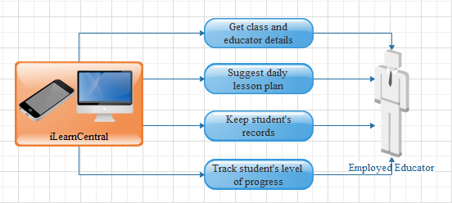

Figure 7: **Teaching Assistance Module Program Workflow**

Figure 7 shows the program workflow for the teaching assistance module. It involves assisting educators with their day to day activities, including lesson plans, record keeping, and tracking student's progression.

**Validation Board (Stages 1 and 2)**

Table 3 shows the different problems that our customers encountered. It also shows the solution to the problem being solved by the researcher. Table 3 also contains the most risky assumption, the methods and the criteria for success, the results and the decision, as well as the learning.

Table 3

VALIDATION BOARD

|  |  |  |  |
| --- | --- | --- | --- |
| Experiments | 1 | 2 | 3 |
| Customer | Learning Center Administration | Employed Educator | Job-Seeking Educators |
| Problem | Learning centers using manual transactions to support common management processes i.e. hiring, enrolment, and scheduling | Variation of lessons for different students handled, maintaining schedules, and keeping records | High turnover of educators in learning centers leading to constant demand amidst particular qualifications. |
| Solution | A dynamic learning center management system supporting different types of learning centers, i.e. day care, music, language studies | Adding a module for educators employed by a center to keep track of lessons, update schedules, and integrate records to the system. | Data pool of job-seeking educators sifted and recommended to fit learning centers' particular needs and vice versa. |
| Riskiest Assumption | Learning Center have no IT support | Learning center provide resources i.e. internet connectivity to employees | Educators uses the system to look for employment in learning centers |
| Method and Success Criteria | 60% of the respondents agree to use the system | 60% of the respondents agree to use the system | 60% of the respondents agree to use the system |

**Gantt Chart**

The Gantt chart shows the scheduled work or activity completion in specific time frames in relation to the amount planned for the specified periods. The chart serves as a guide for the advocates to decide how long a project takes, classify the resources needed, and schedule the order of task completion performed by the researchers.

Table 4

GANTT CHART

|  |  |  |  |  |  |  |  |  |  |  |  |  |  |  |  |  |
| --- | --- | --- | --- | --- | --- | --- | --- | --- | --- | --- | --- | --- | --- | --- | --- | --- |
| Task ID | Task Name | Task Lead | Start Date | End Date | August 2015 | | | | September 2015 | | | | October 2015 | | | |
| 1 | 2 | 3 | 4 | 1 | 2 | 3 | 4 | 1 | 2 | 3 | 4 |
| 1 | Title Consultation |  | Aug 16 | Sep 16 |  |  |  |  |  |  |  |  |  |  |  |  |
| 2 | Project Proposal recommended |  | Sep 16 | Sep 16 |  |  |  |  |  |  |  |  |  |  |  |  |
| 3 | Discussion with adviser | Jephunneh | Sep 19 | Sep 23 |  |  |  |  |  |  |  |  |  |  |  |  |
| 4 | Preliminary research of the project | Cristian | Sep 23 | Sep 26 |  |  |  |  |  |  |  |  |  |  |  |  |
| 5 | Writing and Compiling of Initial and Final Pages | Jephunneh | Sep 23 | Oct 26 |  |  |  |  |  |  |  |  |  |  |  |  |
| 6 | Writing of Chapter 1 | Cristian | Sep 23 | Sep 26 |  |  |  |  |  |  |  |  |  |  |  |  |
| 7 | Consultation with adviser on Chapter 1 | Jephunneh | Sep 27 | Sep 27 |  |  |  |  |  |  |  |  |  |  |  |  |
| 8 | Preparing of Transmittal Letter/s | Rhea Shane | Sep 16 | Sep 23 |  |  |  |  |  |  |  |  |  |  |  |  |
| 9 | Preparing of Questionnaires | Rhea Shane | Sep 16 | Sep 23 |  |  |  |  |  |  |  |  |  |  |  |  |
| 10 | Interviews/Surveys | Rhea Shane | Sep 23 | Oct 11 |  |  |  |  |  |  |  |  |  |  |  |  |
| 11 | Finalizing of Chapter 1 | Cristian | Sep 27 | Sep 28 |  |  |  |  |  |  |  |  |  |  |  |  |
| 12 | Writing of Chapter 2 | Cristian | Sep 29 | Oct 2 |  |  |  |  |  |  |  |  |  |  |  |  |
| 13 | Consultation with adviser on Chapters 1 and 2 | Jephunneh | Oct 2 | Oct 2 |  |  |  |  |  |  |  |  |  |  |  |  |
| 14 | Finalizing of Chapter 2 | Cristian | Oct 2 | Oct 4 |  |  |  |  |  |  |  |  |  |  |  |  |
| 15 | Designing User Interfaces | Cristian | Oct 7 | Oct 17 |  |  |  |  |  |  |  |  |  |  |  |  |
| 16 | Writing of Chapter 3 | Rhea Shane | Oct 7 | Oct 17 |  |  |  |  |  |  |  |  |  |  |  |  |
| 17 | Consultation with adviser on Chapters 1, 2, and 3 | Jephunneh | Oct 18 | Oct 18 |  |  |  |  |  |  |  |  |  |  |  |  |
| 19 | Consultation with Technical Editor | Rhea Shane | Oct 22 | Oct 25 |  |  |  |  |  |  |  |  |  |  |  |  |
| 20 | Finalizing of Chapter 3 | Rhea Shane | Oct 24 | Oct 26 |  |  |  |  |  |  |  |  |  |  |  |  |
| 21 | Concept Video & Presentation preparation | Jephunneh | Oct 21 | Oct 30 |  |  |  |  |  |  |  |  |  |  |  |  |
| 22 | Final consultation with adviser | Jephunneh | Oct 24 | Oct 25 |  |  |  |  |  |  |  |  |  |  |  |  |
| 23 | Compiling and finalizing of Manuscript | Rhea Shane | Oct 24 | Oct 26 |  |  |  |  |  |  |  |  |  |  |  |  |
| 24 | Poster design & preparation | Cristian | Oct 17 | Oct 20 |  |  |  |  |  |  |  |  |  |  |  |  |
| 25 | Proposal presentation |  |  |  |  |  |  |  |  |  |  |  |  |  |  |  |

Table 4 is the Gantt chart for the development of iLearnCentral’s proposal manuscript. Every activity is performed in three different colors: red means that the activity is still incomplete, yellow means that the activity is still on the way, and blue means that the activity is already finished.

**Functional Decomposition Diagram**

The functional decomposition diagram demonstrates the operative relationship between the various components of the project into critical modules to clearly illustrate and simplify various activities.

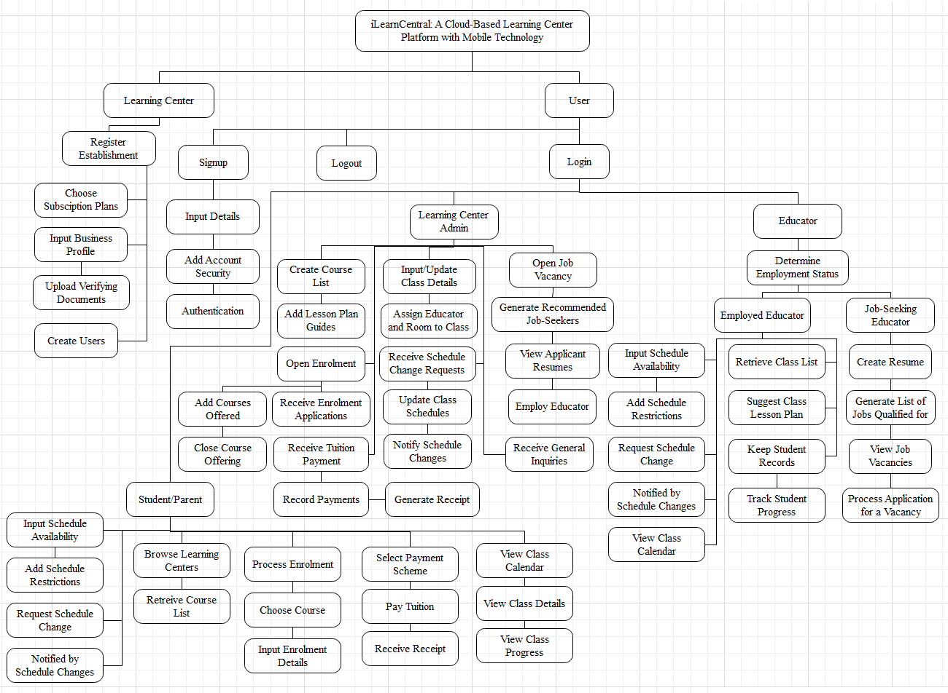

Figure 8: **Functional Decomposition Diagram**

Figure 8 shows the functional decomposition diagram of the system. It displays five modules to complete and sub functions for each module. User types such as learning centers, educators, and students/parents have different access levels, details of which found in the program specification section.

**Analysis / Design Phase**

The stage of analysis includes the concept of the specifications needed to accomplish the method. Each step determines the problem to be solved by the customer.

**Use Case Diagram**

Use case diagram shows the graphic representation of the mechanism of iLearnCentral and potential sequences of interactions between systems and users in a specific environment related to a specific target.

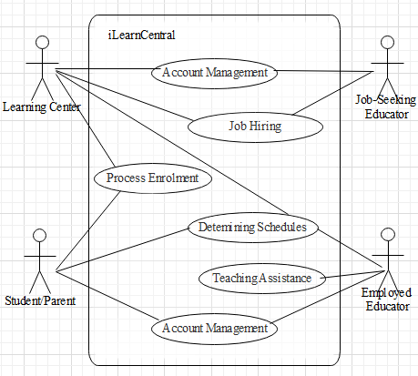

Figure 9: **Use Case Diagram**

Figure 9 shows the use case diagram for iLearnCentral. It shows the outside view of the system and the requirements needed. It identifies the system's influencing external and internal factors and their interactions.

The learning center is a factor in most of the internal modules. Account management involves all actors with varying degrees of complexity for each actor. Job hiring only concerns with the learning center and the job-seeking applicant. Enrolment processing is between the learning center and the students/parents. Determining schedules need the interaction between the learning center, student/parent, and assigned educator. Lastly, teaching assistance is a module for employed educators to utilize.

## Storyboard

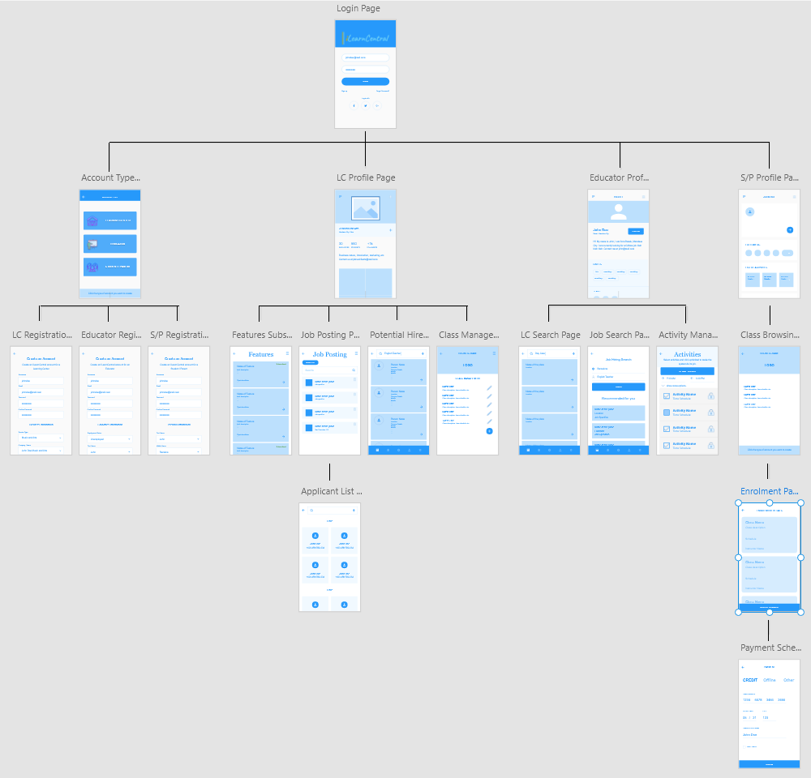

Figure 10: **iLearnCentral Storyboard**

Figure 10 shows the graphical representation of the usage of the app. New users have the option to register as a Learning Center, Educator or Student/Parent and each type of registered user has their own designated profile pages and features.

Learning Centers are able to check their subscriptions, post new jobs, search and hire educator and manage classes. Educators are also able to search for learning centers and jobs, and manage their activities or classes. Lastly, Students/Parents can search for available classes that interest them, view enrolled classes and pay classes on multiple options.

**User Interface Diagram**

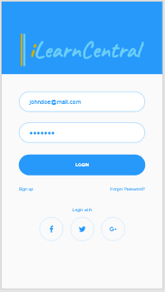

Figure 11: **Login Page**

Figure 11 shows the Login Page. The user can enter their credentials to login. This page also provides links to the registration page and forgot password support page.

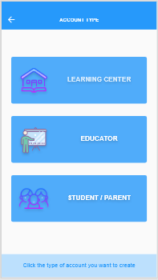

Figure 12: **Account Type Selection Page**

There are three type of users – educator, student/parent and learning center. Users can select the type of account they would like to create.

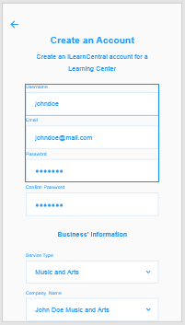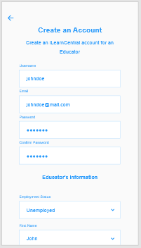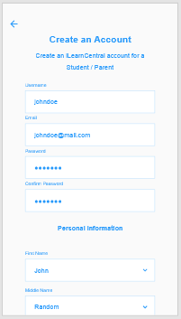

Figure 13: **Sign up Page**

Figure 13 shows the different pages for each of the user sign up types. The sign up page for learning centers is different from the educator and student/parent because the sign up for learning centers require them to specify the type of learning center that they have. The pages show required information for the registration (e.g. First Name, Middle Name, Last Name, Username and Password). Once filled out, users can click on ‘Register’ button to complete the registration or to cancel by clicking the ‘Cancel’ button.

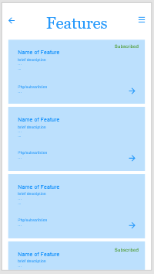

Figure 14: **Feature Subscription Page**

Figure 14 shows the pre-defined features the app offers. After logging in, users select features on this page and install them as an add-on. A feature is either free or subscription-based.

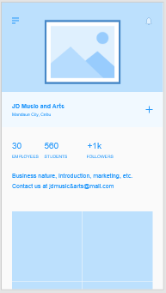

Figure 15: **Learning Center Profile Page**

Figure 15 shows the profile of a learning center. This includes the number of employees, students, followers and contact information.

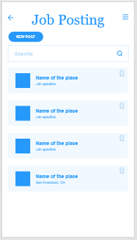

Figure 16: **Job Posting Page**

Figure 16 shows the jobs posted by a learning center. Learning centers also have the option to add new job posting by clicking on the ‘New Post’ button.

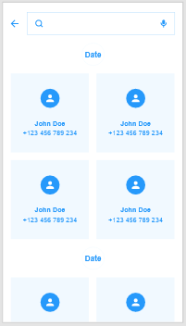

Figure 17: **Applicants List Page**

Figure 17 shows the list of applicants on a posted job. Learning centers have the option to select and hire the educator of their choice.

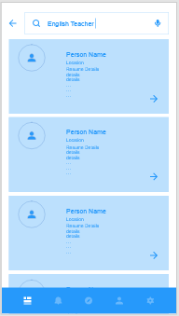

Figure 18: **Potential Hire Search Page**

Figure 18 shows the list of the best applicants determined by the app. Learning centers can search for available educators by use of keywords. Through its Machine Learning, it is able to suggest qualified educators to the posted jobs.

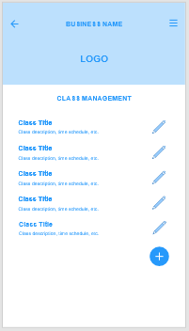

Figure 19: **Class Management Page**

From the Class Management Page, learning centers are able to view all its offered classes. They are also able to add new classes and schedules.

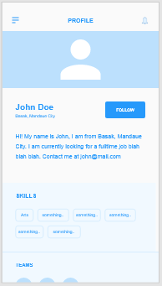

Figure 20: **Educator’s Profile Page**

After registration, they can edit/modify their profile by adding a short description of themselves, skills, etc. from the Educator’s Profile Page. This page also shows whether or not an educator is currently employed to specific learning center/s.

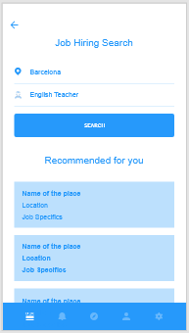

Figure 21: **Job Search Page**

The Job Search Page allows educators to look for posted jobs within their location. They can specify a job search by using keywords. There is a list of recommendations which educators can view and apply.

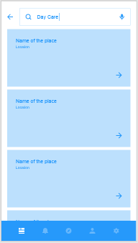

Figure 22: **Learning Center Search Page**

Learning Center Search page allows educators to search for specific type of learning centers.

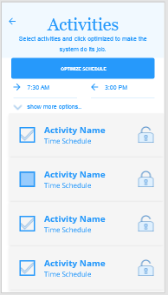

Figure 23: **Activity Management Page**

The Activity Manage Page allows educators to monitor, administer classes and specify activities for the day. This ensures that there is no overlapping of tasks or classes and educators are on top of their schedules.

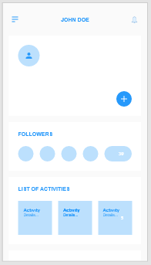

Figure 24: **Student/Parent Profile Page**

The Student/Parent Profile Page mainly shows the classes/activities and basic information about the user.

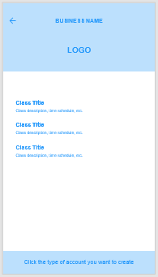

Figure 25: **Class Browsing Page**

In figure 25, students/parents are able to search for classes and schedules from the Class Browsing Page.

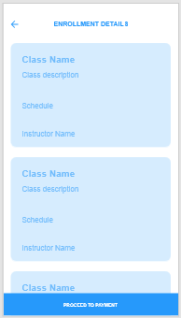

Figure 26: **Enrolment Page**

The Enrolment Page is a digitized form where students process the enrolment of the classes they selected.

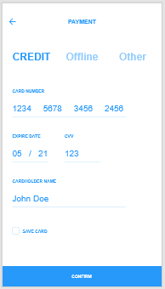

Figure 27: **Payment Scheme Page**

The Payment Scheme Page shows the multiple options for students/parents to pay their classes.

**Database Design**

The database to use is NoSQL due to the advantages it provides with data volume, velocity, and variety. It allows for better adaptability to changes in schema when using agile development. It is scalable and accessible to multitudes of users, which is necessary to a cloud-based system.

This section shows the designed NoSQL schema. The designing process follows the Query Driven Design that optimizes access instead of storage. It is by no means the final structure of the schema as changes may arise during the development process.

A document-oriented database, one of the main categories of NoSQL databases, is a computer program designed to store, retrieve, and handle document-oriented information, also known as semi-structured data. It is inherently a subclass of the key-value store and relies on an internal structure in the document to extract metadata that the database engine uses for further optimization. The current list of features in the documents presented in this section are basic details and more can be added or altered depending on the progress during development phase.

Table 5

USER DOCUMENT

|  |  |
| --- | --- |
| User | |
| PK | username |
|  | password |
|  | emailAddress |
|  | accountType |
|  | securityQuestions [ ]   |  | | --- | | question | | answer | |
|  | accountStatus |

Table 5 is the document database design for all user accounts. The collection of users is solely for account management. Depending on the type of account type, the system proceeds differently. The security questions are the means to provide validation in the event of resetting or retrieving forgotten passwords.

Table 6

LEARNING CENTER DOCUMENT

|  |  |
| --- | --- |
| LearningCenter | |
| PK | centerID |
| FK | accounts [ ]   |  | | --- | | username | | accessLevel | | status | |
|  | businessName |
|  | serviceType |
|  | businessAddress   |  | | --- | | buildingNo | | buildingName | | streetName | | subdivision | | barangay | | district | | city | | province | | country | | zipCode | |
|  | contactEmail |
|  | contactNumber [ ] |
|  | companyWebsite |
|  | operatingDays [ ] |
|  | openingTime |
|  | closingTime |
|  | coursesOffered [ ] |
|  | subscriptionType |
|  | subsciptionEndDate |

Table 6 is the document database design for learning center entities. It records the information about learning centers, including data on identity, operating hours, and subscription to the system. The address is necessary to have segmented documentation for easier processing by the recommendation system in the hiring module.

Table 7

EDUCATOR DOCUMENT

|  |  |
| --- | --- |
| Educator | |
| PK | educatorID |
| FK | username |
|  | name   |  | | --- | | firstName | | middleName | | lastName | | extension | |
|  | birthday |
|  | employmentStatus |
| FK | centerID |
|  | position |
|  | address []   |  | | --- | | houseNo | | streetName | | subdivision | | barangay | | district | | city | | province | | country | | zipCode | | currentAddress | |
|  | email |
|  | phoneNo |
|  | gender |
|  | maritalStatus |
|  | religion |
|  | citizenship |

Table 7 is the document database design for educator entities. It holds the primary information of an educator and represents both employed or job-seeking educators. The employment status and accompanying centerID determines the state of an educator.

Table 8

RESUME DOCUMENT

|  |  |
| --- | --- |
| Resume | |
| PK | resumeID |
| FK | educatorID |
|  | careerObjective |
|  | educationalHistory [ ]   |  | | --- | | educationLevel | | schoolName | | schoolAddress | | course | | major | | yearStart | | yearEnd | | graduated | |
|  | employmentHistory [ ]   |  | | --- | | companyName | | companyAddress | | position | | dateStart | | dateEnd | |
|  | skills [ ] |
|  | qualities [ ] |
|  | interests [ ] |
|  | awards [ ] |
|  | references [ ]   |  | | --- | | referenceName | | affiliation | | position | | contactInfo | |

Table 8 is the document database design for resume entries. It represents the accompanying resume of an educator account and provides the usual information about a job seeker.

Table 9

STUDENT DOCUMENT

|  |  |
| --- | --- |
| Student | |
| PK | studentID |
| FK | username |
|  | name   |  | | --- | | firstName | | middleName | | lastName | | extension | |
|  | birthday |
|  | address []   |  | | --- | | houseNo | | streetName | | subdivision | | barangay | | district | | city | | province | | country | | zipCode | | currentAddress | |
|  | email |
|  | phoneNo |
|  | gender |
|  | maritalStatus |
|  | religion |
|  | citizenship |
| FK | centerID |
|  | enrolmentStatus |
|  | enrolmentHistory [ ] |

Table 9 is the document database design for student entities. Parents and students get one account in our system as they do not have a difference in functionalities directed to them. The expectation is for parents to handle the account for minor students. The document also contains the enrolment history of the student.

Table 10

JOB VACANCY DOCUMENT

|  |  |
| --- | --- |
| JobVacancy | |
| PK | vacancyID |
| FK | centerID  status |
|  | position |
|  | jobDescription |
|  | jobType |
|  | educationalRequirements   |  | | --- | | educationalLevel | | degrees [ ] | | majors [ ] | | minimumUnits | |
|  | qualifications [ ] |
|  | skills [ ] |
|  | incentives [ ] |
|  | responsibilities [ ] |
|  | requirements [ ] |
|  | applicationMethod [ ] |

Table 10 is the document database design for job vacancy events. The job vacancy has to be made by a learning center. It has data on the position to be filled and all pertinent information required to qualify a job-seeker to the job.

Table 11

JOB APPLICATION DOCUMENT

|  |  |
| --- | --- |
| Job Application | |
| PK | jobApplicationID |
| FK | educatorID |
| FK | vacancyID |
|  | applicationDate |
|  | applicationStatus |
|  | preferredMethod |
|  | message |

Table 11 is the document database design for job application events. A job application happens when a job seeker applies for an available job vacancy. The learning center receives a list of recommended applicants as well as job-seekers who manually applied.

Table 12

COURSE DOCUMENT

|  |  |
| --- | --- |
| Course | |
| PK | courseID |
| FK | centerID |
|  | courseName |
|  | courseDescription |
|  | tuition |

Table 12 is the document database design for course entities. The courses are services offered by a learning center and the basis for enrolment and classes.

Table 13

ENROLMENT DOCUMENT

|  |  |
| --- | --- |
| Enrolment | |
| PK | enrolmentID |
| FK | centerID |
| FK | studentID |
|  | enrolmentDate |
|  | dateClassStart |
|  | dateClassEnds |
|  | noOfHours |
|  | enrolmentStatus |

Table 13 is the document database design for enrolment events. Details of an enrolment process are stored here. Information about the learning center and student involved retrieves from their document store via foreign keys.

Table 14

PAYMENT DOCUMENT

|  |  |
| --- | --- |
| Payment | |
| PK | paymentID |
| FK | enrolmentID |
|  | tuition |
|  | additionalFees |
|  | balance |
|  | payments [ ]   |  | | --- | | paymentDate | | amount | | paymentMethod | | validated | |
|  | status |

Table 14 is the document database design for a payment plan. An entry of the payment document is a counterpart of an enrolment. It records the progress of payments made, be it one-time full payment or each staggering pay. The record also contains the details of the fees needed.

Table 15

CLASS SESSION DOCUMENT

|  |  |
| --- | --- |
| ClassSession | |
| PK | classSessionID |
| FK | courseID |
| FK | enrolmentID |
| FK | educatorID |
|  | date |
|  | timeStart |
|  | timeEnd |
|  | roomNo |

Table 15 is the document database design for a class session. Class sessions contain details of meetups between students and educators. Learning centers are tasked to set up the classes.

Table 16

SCHEDULE REQUEST DOCUMENT

|  |  |
| --- | --- |
| ScheduleRequest | |
| PK | scheduleRequestID |
|  | restrictionType |
| FK | educatorID |
| FK | studentID |
| FK | centerID |
| FK | classSessionID |
|  | scheduleDate |
|  | timeStart |
|  | timeEnd |

Table 16 is the document database design for schedule requests. The requests are days and times a student or educator scheduled to open or restrict and help the scheduling module determine when to place classes.

Table 17

LESSON PLAN DOCUMENT

|  |  |
| --- | --- |
| LessonPlan | |
| PK | lessonID |
| FK | courseID |
|  | topic |
|  | overview |
|  | objective [ ] |
|  | materials [ ] |
|  | activities [ ] |
|  | procedures [ ] |

Table 17 is the document database design for lesson plans. It contains the different sections in building lesson plans. An educator may add multiple instances of each part. Lesson plans are reusable and shareable across educators within the learning center.

Table 18

STUDENT RECORD DOCUMENT

|  |  |
| --- | --- |
| StudentRecord | |
| PK | studentRecordID |
| FK | enrolmentID |
|  | lessonPlansCovered [ ] |
| FK | classSession [ ]   |  | | --- | | classSessionID | | remarks | |
|  | studentScores [ ]   |  | | --- | | testTitle | | score | | perfectscore | | testDate | |

Table 18 is the document database design for student records. It means to keep track of student progress and data. It links to lesson plans and histories of sessions attended. It records test scores, if available.

**Entity-Relationship Diagram**

The entity-relationship diagram graphically demonstrates the interactions of entities, activities, events, and relationships across all modules of the system.

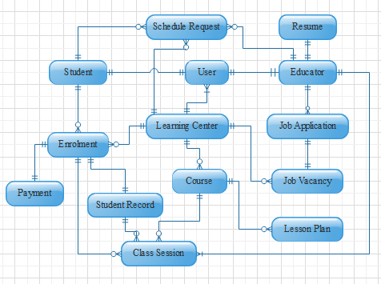

Figure 28: **Entity Relationship Diagram**

Figure 28 shows the entity-relationship diagram of iLearnCentral's database. The user is an entity that holds account management information used for login, password recovery, registration, and verification. Multiple user accounts are within a learning center with different access levels, while one user account per student and educator. The account management module handles user accounts.

The resume, job application, and job vacancy are document stores for profiling and hiring. Each educator is allowed to have one and only one resume. Meanwhile, learning centers can make multiple job vacancies for which educators can apply.

The enrolment module utilizes the course list and creates enrolment entries with payment instances. A single payment instance records the information for an enrolment's payment scheme and progress of installments.

The schedule request is the basis for scheduling classes. Class scheduling depends on the restrictions from students, educators, and learning centers. A student has classes from an enrolled course with many sessions assigned to one or different educators.

The teaching assistance involves the lesson plan and student record documents. The lesson plan segregates by course, while student records by enrolment.

**Data Dictionary**

The data dictionary describes the types of data, properties and field sizes shown in the tables in the previous section. The tables below are data dictionaries for each table in the database.

Table 19

DATABASE DATA DICTIONARY

|  |  |  |  |  |  |
| --- | --- | --- | --- | --- | --- |
| Table | **Key Name** | **Data Type** | **Field Size** | **Null** | **Description** |
| User | username | varchar | 20 | not null | the name the user uses to login |
| User | password | varchar | 20 | not null | value used to verify the identity of a user |
| User | emailAddress | varchar | 30 | not null | valid email address for account verification |
| User | accountType | varchar | 20 | not null | determines the user account designation |
| User | securityQuestions | list |  | not null | array of security questions used for validating user identity |
| User | question | varchar | 50 | not null | single security question |
| User | answer | varchar | 20 | not null | answer to a security question |
| User | accountStatus | varchar | 20 | not null | the state of the user if they are validated, etc. |
| Learning Center | centerID | long | 20 | not null | primary key for learning center document |
| Learning Center | accounts | list |  | not null | array of user accounts in a learning center entry |
| Learning Center | username | varchar | 20 | not null | foreign key for the name user uses to login |
| Learning Center | accessLevel | varchar | 10 | not null | access levels to determine how a user can use the learning center's features |
| Learning Center | status | varchar | 10 | not null | status of a user account in learning center |
| Learning Center | businessName | varchar | 100 | not null | complete business name of a learning center |
| Learning Center | serviceType | varchar | 50 | not null | type of service provided by learning center |
| Learning Center | businessAddress |  |  |  | address of business |
| Learning Center | buildingNo | varchar | 10 | null | building number part of the address |
| Learning Center | buildingName | varchar | 20 | null | building name part of the address |
| Learning Center | streetName | varchar | 20 | null | streetName part of the address |
| Learning Center | subdivision | varchar | 20 | null | subdivision part of the address |
| Learning Center | barangay | varchar | 20 | not null | barangay part of the address |
| Learning Center | district | varchar | 10 | null | district part of the address |
| Learning Center | city | varchar | 20 | not null | city part of the address |
| Learning Center | province | varchar | 20 | not null | province part of the address |
| Learning Center | country | varchar | 20 | not null | country part of the address |
| Learning Center | zipCode | int | 4 | not null | zip code part of the address |
| Learning Center | contactEmail | varchar | 30 | not null | official learning center email address |
| Learning Center | contactNumber | varchar | 20 | not null | contact numbers for learning center |
| Learning Center | companyWebsite | varchar | 30 | null | website to visit and learn more about learning center |
| Learning Center | operatingDays | list |  | not null | days the learning center is open |
| Learning Center | openingTime | time |  | not null | time the learning center opens |
| Learning Center | closingTime | time |  | not null | time the learning center closes |
| Learning Center | coursesOffered | list |  |  | list of courses offered by the learning center |
| Learning Center | subscriptionType | varchar | 10 | not null | determines the current subscription |
| Learning Center | subscriptionEndDate | date |  | null | date when a subscription ends and reverts to limited |
| Educator | educatorID | long | 20 | not null | primary key for educator |
| Educator | username | varchar | 20 | not null | foreign key for name of user used to log in |
| Educator | name |  |  |  | name of educator |
| Educator | firstName | varchar | 50 | not null | first name of person |
| Educator | middleName | varchar | 20 | null | middle name of person |
| Educator | lastName | varchar | 20 | not null | last name of person |
| Educator | extension | varchar | 10 | null | extensions to name such as Sr., Jr., III, IV, etc. |
| Educator | birthday | date |  | not null | birthdate of educator |
| Educator | address | list |  |  | addresses of an educator |
| Educator | houseNo | int | 10 | null | house number part of the address |
| Educator | streetName | varchar | 20 | null | street number part of the address |
| Educator | subdivision | varchar | 20 | null | subdivision part of the address |
| Educator | district | varchar | 10 | null | district part of the address |
| Educator | city | varchar | 20 | not null | city part of the address |
| Educator | province | varchar | 20 | not null | province part of the address |
| Educator | country | varchar | 20 | not null | country part of the address |
| Educator | zipCode | int | 4 | not null | zip code part of the address |
| Educator | currentAddress | boolean |  | not null | tag determining if the address is the current one |
| Educator | email | varchar | 30 | not null | email address of educator |
| Educator | phoneNo | varchar | 15 | not null | contact no of educator |
| Educator | gender | char | 1 | not null | gender of educator (F, M) |
| Educator | maritalStatus | varchar | 10 | not null | marital status of an educator |
| Educator | religion | varchar | 30 | null | religion of the educator |
| Educator | citizenship | varchar | 30 | null | citizenship of the educator |
| Educator | employmentStatus | varchar | 10 | not null | status of employment in respect to learning centers in the system |
| Educator | centerID | int | 10 | null | foreign key for centerID employing this educator |
| Educator | position | varchar | 20 | null | position for employed educators in a learning center |
| Resume | resumeID | long | 20 | not null | primary key for resume document |
| Resume | educatorID | long | 20 | not null | foreign key to distinguish the owner of resume document |
| Resume | careerObjective | varchar | 500 | null | short description for career objectives in a resume |
| Resume | educationalHistory | list |  |  | list of educational history of an educator |
| Resume | educationLevel | varchar | 20 | not null | determines the level of education i.e. elementary, college |
| Resume | schoolName | varchar | 100 | not null | school name of previous education |
| Resume | schoolAddress | varchar | 300 | not null | address of the school |
| Resume | course | varchar | 100 | null | course taken |
| Resume | major | varchar | 50 | null | major taken during the course |
| Resume | yearStart | int | 4 | not null | starting year in this school |
| Resume | yearEnd | int | 4 | not null | ending year in this school |
| Resume | graduated | boolean |  | not null | true if graduated, false if undergraduate |
| Resume | employmentHistory | list |  |  | list of employment history of an educator |
| Resume | companyName | varchar | 100 | not null | name of previous company |
| Resume | companyName | varchar | 300 | not null | address of previous company |
| Resume | position | varchar | 100 | not null | position or job description of previous company |
| Resume | dateStart | date |  | not null | date started with previous employment |
| Resume | dateEnd | date |  | not null | date ended with previous employment |
| Resume | skills | list |  | null | list of skills in a resume |
| Resume | qualities | list |  | null | list of qualities in a resume |
| Resume | interests | list |  | null | list of interests in a resume |
| Resume | awards | list |  | null | list of awards in a resume |
| Resume | references | list |  | null | list of references for individual |
| Resume | referenceName | varchar | 50 | not null | name of reference |
| Resume | affiliation | varchar | 100 | not null | company of the reference |
| Resume | position | varchar | 50 | not null | position of the reference in their company |
| Resume | contactInfo | varchar | 30 | not null | contact information of the reference |
| Student | studentID | long | 20 | not null | primary key for the student document |
| Student | username | varchar | 20 | not null | foreign key for name of user used to log in |
| Student | name |  |  |  | name of student |
| Student | firstName | varchar | 50 | not null | first name of person |
| Student | middleName | varchar | 20 | null | middle name of person |
| Student | lastName | varchar | 20 | not null | last name of person |
| Student | extension | varchar | 10 | null | extensions to name such as Sr., Jr., III, IV, etc. |
| Student | birthday | date |  | not null | birthdate of educator |
| Student | address | list |  |  | addresses of an educator |
| Student | houseNo | int | 10 | null | house number part of the address |
| Student | streetName | varchar | 20 | null | street number part of the address |
| Student | subdivision | varchar | 20 | null | subdivision part of the address |
| Student | district | varchar | 10 | null | district part of the address |
| Student | city | varchar | 20 | not null | city part of the address |
| Student | province | varchar | 20 | not null | province part of the address |
| Student | country | varchar | 20 | not null | country part of the address |
| Student | zipCode | int | 4 | not null | zip code part of the address |
| Student | currentAddress | boolean |  | not null | tag determining if the address is the current one |
| Student | email | varchar | 30 | not null | email address of educator |
| Student | phoneNo | varchar | 15 | not null | contact no of educator |
| Student | gender | char | 1 | not null | gender of educator (F, M) |
| Student | maritalStatus | varchar | 10 | not null | marital status of an educator |
| Student | religion | varchar | 30 | null | religion of the educator |
| Student | citizenship | varchar | 30 | null | citizenship of the educator |
| Student | centerID | int | 10 | null | centerID for the current learning center enrolled in |
| Student | enrolmentStatus | varchar | 10 | null | status of enrolment |
| Student | enrolmentHistory | list |  |  | list of enrolmentIDs, foreign key, of instances of enrolment made by the student |
| Job vacancy | vacancyID | long | 20 | not null | primary key for job vacancy entries |
| Job vacancy | centerID | long | 20 | not null | foreign key for Learning center creator of job vacancy |
| Job vacancy | status | varchar | 10 | not null | status of the job vacancy i.e. active, cancelled, filled |
| Job vacancy | position | varchar | 30 | not null | position to be filled |
| Job vacancy | jobDescription | varchar | 400 | null | description of the job position |
| Job vacancy | jobType | varchar | 25 | not null | type of job i.e. full-time, part-time, full-time or part-time |
| Job vacancy | educationalRequirements | list |  |  | requirements based on educational attainment |
| Job vacancy | educationalLevel | varchar | 200 | not null | educational attainment needed i.e. high school graduate, college level |
| Job vacancy | degrees | list |  | null | degrees earn from school i.e. bachelor of Secondary Education |
| Job vacancy | majors | list |  | null | major taken during from the degrees |
| Job vacancy | minimunUnits | int |  | null | minimum number of units required |
| Job vacancy | qualifications | list |  | not null | list of qualifications needed |
| Job vacancy | skills | list |  | null | list of skills needed |
| Job vacancy | incentives | list |  | null | list possible incentives to entice applicants |
| Job vacancy | responsibilities | list |  | null | list of possible responsibilities |
| Job vacancy | requirements | list |  | null | list of what requirements applicants need to give |
| Job vacancy | applicationMethod | varchar |  | null | list of ways to apply |
| Jobapplication | jobApplicationID | long | 20 | not null | primary key for job application |
| Jobapplication | educatorID | long | 20 | not null | foreign key to the educator making the job application |
| Jobapplication | vacancyID | long | 20 | not null | foreign key for the vacancy applied for |
| Jobapplication | applicationDate | date |  | not null | date the job was applied to |
| Jobapplication | applicationStatus | varchar |  | not null | status of the application i.e. pending, accepted, rejected |
| Jobapplication | preferredMethod | varchar |  | null | what way the application was done i.e. walk-in |
| Jobapplication | message | varchar | 10000 | null | optional message to the learning center |
| Course | courseID | long | 20 | not null | primary key for the course |
| Course | centerID | long | 20 | not null | foreign key for the center offering the course |
| Course | courseName | varchar | 100 | not null | name of course or class offered |
| Course | courseDescription | varchar | 500 | not null | description of the course or class offered |
| Course | courseType | varchar | 30 | null | if any, the course type |
| Course | tuition | float |  | null | tuition amount for a course |
| Enrolment | enrolmentID | long | 20 | not null | primary key for enrolment |
| Enrolment | centerID | long | 20 | not null | foreign key to which center |
| Enrolment | studentID | long | 20 | not null | foreign key to which student |
| Enrolment | courseID | long | 20 | not null | foreign key to course enrolled |
| Enrolment | enrolmentDate | date |  | not null | date enrolment occurred |
| Enrolment | dateClassStart | date |  | null | date for start of classes |
| Enrolment | dateClassEnds | date |  | null | date for end of classes |
| Enrolment | noOfHours | int | 5 | null | number of hours for the course |
| Enrolment | enrolmentStatus | varchar | 20 | not null | status of the enrolment |
| Payment | paymentID | long | 20 | not null | primary key for payment |
| Payment | enrolmentID | long | 20 | not null | foreign key for enrolment |
| Payment | tuition | float |  | not null | tuition amount |
| Payment | additionalFees | float |  | null | amount of additional fees |
| Payment | balance | float |  | not null | current balance |
| Payment | payments | list |  | null | list of payments made |
| Payment | paymentDate | date |  | not null | date a payment is made |
| Payment | amount | float |  | not null | amount, partial or full for payment |
| Payment | paymentMethod | varchar | 40 | not null | method the payment is made |
| Payment | validated | boolean |  | not null | validation for payment |
| Payment | status | varchar | 20 | not null | status of payment, complete or with balance |
| Class session | classSessionID | long | 20 | not null | primary key for the class instance |
| Class session | enrolmentID | long | 20 | not null | foreign key of the enrolment basis of the class |
| Class session | educatorID | long | 20 | null | educator assigned to the class |
| Class session | date | date |  | not null | the date of the class |
| Class session | timeStart | time |  | not null | the time the class start |
| Class session | timeEnd | time |  | not null | the time it should end |
| Class session | roomNo | varchar |  | not null | the room number assigned to the class |
| ScheduleRequest | scheduleRequestID | long |  | not null | primary key for schedule restriction request |
| ScheduleRequest | restrictionType | varchar | 50 | not null | type of restriction i.e. available, restricted |
| ScheduleRequest | educatorID | long | 20 | null | foreign key to educator requesting the schedule |
| ScheduleRequest | studentID | long | 20 | null | foreign key to student requesting the schedule |
| ScheduleRequest | centerID | long | 20 | not null | foreign key to learning center requested to |
| ScheduleRequest | classSessionID | long | 20 | null | foreign key for the specific class if necessary |
| ScheduleRequest | scheduleDate | date |  | not null | the date a schedule is requested |
| ScheduleRequest | timeStart | time |  | null | a possible start time of schedule request |
| ScheduleRequest | timeEnd | time |  | null | a possible end time of schedule request |
| Lesson Plan | lessonID | long | 20 | not null | primary key for lesson plan |
| Lesson Plan | courseID | long | 20 | not null | foreign key for learning center |
| Lesson Plan | topic | varchar | 100 | not null | topic of the lesson plan |
| Lesson Plan | overview | varchar | 500 | null | short description of the topic to plan for |
| Lesson Plan | objective | list |  | null | a list of objectives for the lesson plan |
| Lesson Plan | materials | list |  | null | a list of materials for the lesson plan |
| Lesson Plan | activities | list |  | null | a list of activities for the lesson plan |
| Lesson Plan | procedures | list |  | null | a list of procedures for the lesson plan |
| StudentRecord | studentRecordID | long | 20 | not null | primary key for student record |
| StudentRecord | enrolmentID | long | 20 | not null | foreign key to enrolment id associated with record |
| StudentRecord | lessonPlanCovered | list |  | null | the lesson plans tackled by the student |
| StudentRecord | classSession | list |  | null | the class sessions the student showed up to |
| StudentRecord | classSessionID | long | 20 | not null | foreign key to the class session ID |
| StudentRecord | remarks | varchar | 500 | null | remarks an educator can give to the student |
| StudentRecord | studentScores | list |  | null | possible scores for student when tests occur |
| StudentRecord | testTitle | varchar | 200 | not null | title for the test |
| StudentRecord | score | int | 20 | not null | score the student got |
| StudentRecord | perfectscore | int | 20 | not null | perfect score the student can get |
| StudentRecord | testDate | date |  | not null | date the score was taken |

Table 19 displays the data dictionary of all documents in the database. It contains the description for each detail in the records. For some NoSQL servers, the Varchar data type may be String. To find the primary and foreign keys refer to the database design section.

**Network Model**

The model of the network shows how the system components communicate via the internet. The diagram shows that the user is able to check and monitor their account through application for possible breaches or errors.

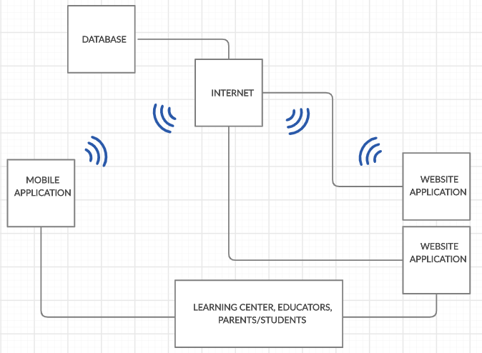

Figure 29: **Network Model**

Figure 29 shows the network model of the system. Internet is used for both web and mobile app to interact with the database.

**Network Topology**

The network topology illustrates how the system's component work in conjunction with the use of internet connection to access the user's access database.

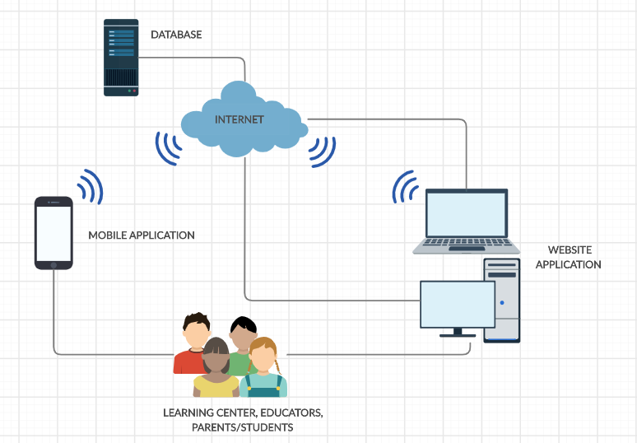

Figure 30: **Network Topology**

Figure 30 shows the network topology of the system. As shown the user can use both web and mobile app with the help of the internet. They can manage classes, check schedules, post and search jobs, etc.

**Development/Construction/Build Phase**

The Development Phase marks the end of the initial process segment and marks the beginning of development. This phase is intended to turn the prototyped system design in the Design Phase into a working system that meets all defined system requirements. Two elements are required to complete this phase successfully: 1) a complete set of design specifications and 2) proper processes, standards and tools.

**Technology Stack Diagram**

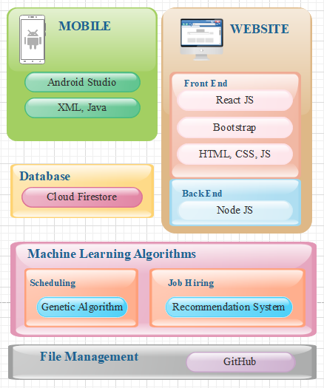

Figure 31: **Technology Stack Diagram**

Figure 31 shows the technology stack diagram representing the different technologies the project uses and the purpose for each specific language.

**Android Studio** is an integrated development environment for the Android operating system. It was built on JetBrains' IntelliJ IDEA software and designed for android development. It comprises both frontend and backend development by using XML and java.

**XML**,meaning eXtensible Markup Language, is a markup language built as a standard way to encode data in internet-based applications. Android uses it in creating layouts and components as Front End for typical applications.

**Java** is one of the languages used in android development. Java's mobile version is called Java ME. Many smartphones and tablets support it. The Java Platform Micro Edition (Java ME) provides a flexible, secure environment for building and running applications that target embedded and mobile devices. Java ME addresses the challenge of running applications on devices that are low on memory, display, and power available.

**ReactJs** is a JavaScript library that is declarative, powerful and scalable to create user interfaces. This allows complex UIs to be constructed from small and isolated pieces of code called "components."

**Bootstrap** is a free and open-source front end development platform for website and web app construction. The architecture for Bootstrap is based on HTML, CSS, and JavaScript (JS) to promote the development of responsive, first mobile sites and apps.

**HTML**, or HyperText Markup Language, is the standard markup language for creating Web pages. It describes the structure of a Web page. Consisting of a series of elements or tags, it tells the browser how to display content.

**CSS**, short for Cascading Style Sheets, a new feature introduced to HTML that provides more control over how pages present to both website developers and users.

**JavaScript** is a scripting language on the client-side. It means that the web browser of the client interprets the source code instead of the webserver. JavaScript functions can run without interacting with the server after a web page loads.

**Node.js** (Node) is an open-source framework for the server-side execution of JavaScript code. Node is useful for developing applications requiring a persistent connection between the browser and the server and is often used for real-time applications such as chat, news feeds, and web push notifications.

**Cloud Firestore** is a repository of NoSQL documents designed for automatic scaling, high performance, and ease of application development.

**Genetic Algorithm** is a search heuristic based on Charles Darwin's theory of natural evolution. The algorithm reflects the natural selection process in which the most suitable individuals are selected for reproduction to produce the next-generation offspring. It consists of five phases–initial population, fitness function, selection, crossover, and mutation.

**Recommendation system** is a group of machine learning algorithms that strives to predict user preferences and make suggestions that clients would be interested in. It has two approaches to making recommendations–collaborative filtering and content filtering. Collaborative filtering involves comparing the behavior of similar groups to predict what a user, with likely behaviors, would want. Meanwhile, content filtering is based on a description of the item and a profile of the user's preferences.

**GitHub** is a system used to store a project's source code and record any modifications to that code in its entire history. It allows developers to work more efficiently on a project by providing resources from different developers to manage potentially conflicting changes.

**Software Specification**

The software specification describes the functional requirements of the study. It includes the programming language, platform for development, management of the database, and machine learning algorithms.

The mobile development uses Android Studio IDE with Java being the back end programming language, and XML for front end builds. The mobile application is for Android devices. The development uses minimum API Level 21 to run with devices Android 5.0 Lollipop and higher. The researchers decided with the minimum API based on the worldwide Android version distribution, according to Holst (2019) and Protalinski (2019), where roughly 90% of devices running in Android have versions 5.0 and higher.

The website or web app development involves the use of Node Js for backend support. For the frontend, React js is the primary framework to create the components with Bootstrap providing design beatification. HTML, CSS, and Javascript are additional languages to use when necessitated. Sublime IDE is the preferred environment used to code the web app. However, collaborators may use other applications suitable for the purpose.

Genetic algorithm is the preferred machine learning algorithm to use for scheduling classes. Making of class schedules are NP-hard problems and does not have a definite correct answer, only an optimal one. The heuristic approach is usually enough for simple cases but with the complexity of the system. It is decided to go with a Genetic Algorithm for a better solution.

The hiring module makes use of Recommendation systems to efficiently suggest a list of qualified job seekers to a learning center with job vacancies and a list of job vacancies to a job seeker. Content-filtering is the initial approach to the small dataset until such time when collaborative filtering can add to the efficiency of the recommendations.

Cloud Firestore is the database of choice to support the project. Both mobile and web application connects to Firestore for all data. GitHub supports the collaboration of the members and allows them to code concurrently for more efficient and time-conscious development.

**Program Specifications**

Program specifications contain the list of algorithms needed for the system.

Table 20

SOFTWARE LIST OF MODULES

|  |  |  |  |  |
| --- | --- | --- | --- | --- |
| **Programmer/s** | **Modules** | **Learning Center** | **Educator** | **Parent or Student** |
| Jephunneh  Rhea Shane  Cristian | **Account Management** |
| 1. Registration | * | * | * |
| 2. Authentication | * | * | * |
| 3. Login | * | * | * |
| 4. Profiling | * | * |  |
| No. of Points *(1 point per module per user)* | | 1 | 1 | 1 |
| Jephunneh  Rhea Shane  Cristian | **Hiring Module** |  | | |
| 1. Hiring Profile/Resume |  | * |  |
| 2. Job Searching |  | * |  |
| 3. Job Posting | * |  |  |
| 4. Job Suggestion |  | * |  |
| 5. Hire Suggestion | * |  |  |
| 6. Hiring | * |  |  |
| No. of Points *(1 point per module per user)* | | 1 | 1 | 0 |
| Jephunneh  Rhea Shane  Cristian | **Enrollment Module** |  | | |
| 1. Input/Add Course Details | * |  |  |
| 2. Search/Display Course List | * | * | * |
| 3. Course Selection |  |  | * |
| 4. Fee Calculation |  |  | * |
| 5. Enrolment Details and Processes |  |  | * |
| 6. Payment Scheme Selection |  |  | * |
| 7. Payment |  |  | * |
| 8. Record Payment | * |  | * |
| No. of Points *(1 point per module per user)* | | 1 | 1 | 1 |
| Jephunneh  Rhea Shane  Cristian | **Scheduling Module** |  | | |
| 1. Input Class Details | * |  |  |
| 2. Update Class Details | * |  |  |
| 3. Input Schedules | * |  |  |
| 4. Schedule Request |  | * | * |
| 5. Update Schedules | * |  |  |
| 6. Generate Calendar of Activities | * | * | * |
| 7. Notification of Changes | * | * | * |
| No. of Points *(1 point per module per user)* | | 1 | 1 | 1 |
| Jephunneh  Rhea Shane  Cristian | **Teaching Assistance Module** |  | | |
| 1. Retrieve Class Details |  | * |  |
| 2. Suggest Daily Lesson Plan |  | * |  |
| 3. Keep Student Records |  | * |  |
| 4. Track Student Progress |  | * |  |
| No. of Points *(1 point per module per user)* | | 0 | 1 | 0 |
| Number of Modules per User *(equals total no. of points per user)* | | 4 | 5 | 3 |
| Total Number of Modules | | 12 | | |

Table 20 shows the comparison of the access level of each type of account. The table shows that multiple types of accounts or a specific type of account can access a module. It also shows the programmer/s assigned to develop per module.

**REFERENCES**

**BOOKS**

Beck, K., Beedle, M., Van Bennekum, A., Cockburn, A., Cunningham, W., Fowler, M., ... & Kern, J. (2001). Manifesto for agile software development.

Bruce, C., Hughes, H., & Somerville, M. (2012) Supporting informed learners in the 21st century. *Library Trends*, 60(3).

Chatterjee, S. (2014). *International Journal of Interdisciplinary and Multidisciplinary Studies (IJIMS)*

Hudson, M. (2017, January 16). *Preschool Educators Play an Important Role in Children’s Growth*

Martinez-Beck & Zaslow, 2006 Martinez-Beck, I. and Zaslow, M. 2006. “Introduction: The context for critical issues in early childhood professional development.”. *In Critical issues in early childhood professional development* Edited by: Zaslow, M. and Martinez-Beck, I. 1–16. Baltimore: Brookes.

Sheridan, S., Edwards, C., Marvin, C. &. Knoche, L. (2009) *Professional Development in Early Childhood Programs: Process Issues and Research Needs, Early Education and Development*, 20:3, 377-401, DOI: [10.1080/10409280802582795](https://doi.org/10.1080/10409280802582795)

Welch-Ross, M., Wolf, A., Moorehouse, M. and Rathgeb, C. 2006. “Improving connections between professional development research and early childhood policies.”. In *Critical issues in early childhood professional development* Edited by: Zaslow, M. and Martinez-Beck, I. 369–394. Baltimore: Brookes.

Yoshino, N., & Taghizadeh Hesary, F. (2016). *Major challenges facing small and medium-sized enterprises in Asia and solutions for mitigating them*.

**JOURNALS**

Buckley, P. & Minette, K. & Joy, D. & Michaels, J. (2004). *The Use of an Automated Employment Recruiting and Screening System for Temporary Professional Employees: A Case Study. Human Resource Management*. 43. 233 - 241. 10.1002/hrm.20017.

Gluck, Samantha. (n.d.). “*Benefits Vs. Risks of Outsourcing IT Services. Small Business*” Chron.com. Retrieved from <http://smallbusiness.chron.com/benefits-vs-risks-outsourcing-services-2504.html>

Ingersoll, R. 2003. “Educator Turnover and Educator Shortages: An Organizational Analysis. University of Pennsylvania.” *American Educational Research Journal*, 38(3): 499-534.

Ingersoll, R., & Smith, T. M. (2003). The Wrong Solution to the Teacher Shortage. Retrieved from https://repository.upenn.edu/gse_pubs/126

Oksanen, R. “*New technology-based recruitment methods*” Research Gate. Retrieved September 30, 2019, from <https://www.researchgate.net/publication>

Sharma, S., Sarkar, D., & Gupta, D. (2012). Agile processes and methodologies: A conceptual study. International journal on computer science and Engineering, 4(5), 892.

UNESCO (2019). *“e-Skwela: Community-based E-learning Centers for Out-of-School Youth and Adults, Philippines”*. In Search of Innovative ICT in Education Practices: Case Studies from the Asia-Pacific Region, pp. 1 – 2.

**NEWSPAPERS**

(“Cebu sweep top awards,” 2018, July). Cebu schools sweep top awards at innovation competition. Retrieved from <https://www.sunstar.com.ph/article/1750606>

**OTHERS**

Holst, A. (2019). *Mobile Android operating system market share by version worldwide from January 2018 to July 2019\**. Retrieved from [https://www.statista.com/statistics/921152/ mobile-android-version-share-worldwide/](https://www.statista.com/statistics/921152/mobile-android-version-share-worldwide/)

Protalinski, E. (2019). *Google finally updates Android distribution dashboard, Pie passes 10%*. Retrieved from <https://venturebeat.com/2019/05/07/google-finally-updates-android-distribution-dashboard-pie-passes-10/>

**CURRICULUM VITAE**

**PERSONAL DATA**

**NAME** **:** Jephunneh C. Mabini

**DATE OF BIRTH :** December 07, 1990

**ADDRESS :** 063 Sitio Riles, Basak, Mandaue City,

Cebu 6014, Philippines

**GENDER :** Male

**CIVIL STATUS :** Single

**EMAIL :** mcjeph@gmail.com

**CONTACT NUMBER :** 09120752272

**EDUCATIONAL BACKGROUND**

**COLLEGE :** Bachelor of Science in Information Technology

University of Cebu – Banilad Campus

Banilad, 6000 Cebu City, Philippines

School Year 2017 – Present

**HIGH SCHOOL :** Antique National High School

San Jose de Buenavista, Antique, Philippines

School Year 2006 - 2008

Mandaue City Comprehensive National High School

Jose L.Briones, Mandaue City, 6014 Cebu

School Year 2004 - 2006

**ELEMENTARY :** Basak Elementary School

Basak, Mandaue City, Philippines

School Year 1997 – 2004

**PERSONAL DATA**

**NAME** **:** Cristian G. Paragoso

**DATE OF BIRTH :** December 11, 1986

**ADDRESS :** 296-M Gonzales Compound,

Gorordo Ave., Brgy. Camputhaw,

Cebu City, 6000

**GENDER :** Male

**CIVIL STATUS :** Single

**EMAIL :** cparagoso@gmail.com

**CONTACT NUMBER :** 09158416454

**EDUCATIONAL BACKGROUND**

**COLLEGE :** Bachelor of Science in Information Technology

University of Cebu – Banilad Campus

Banilad, Cebu City

School Year 2012 – Present

Bachelor of Science in Electronics & Communications Engineering

University of San Jose – Recoletos

Magallanes St., Cebu City

2003 - 2009

**HIGH SCHOOL :** The Sisters of Mary Boystown School

Tungkop, Minglanilla, Cebu

School Year 1999 - 2003

**ELEMENTARY :** Tungkop Elementary School

Tungkop, Minglanilla, Cebu

School Year 1993 – 1999

**PERSONAL DATA**

**NAME** **:** Rhea Shange M. Chiong

**DATE OF BIRTH :** July 22, 1992

**ADDRESS :** 0440 Sitio BACA, Apas, Cebu City

**GENDER :** Female

**CIVIL STATUS :** Single

**EMAIL :** rheashanechiong@gmail.com

**CONTACT NUMBER :** 09225011284

**EDUCATIONAL BACKGROUND**

**COLLEGE :** Bachelor of Science in Information Technology

University of Cebu – Banilad Campus

Banilad, Cebu City

School Year 2017 – Present

Bachelor of Science in Computer Science

University of the Philippines Cebu

Gorordo Ave., Lahug, Cebu City

School Year 2009 – 2014

**HIGH SCHOOL :** University of the Philippines High School Cebu

Gorordo Ave., Lahug, Cebu City

School Year 2005 – 2009

**ELEMENTARY :** Cebu Bradford School

340 – P Ascencion Street, Urgello, Cebu City

School Year 1999 – 2005

**Appendix A**

Working Title Form



**Appendix B**

Consultation Log Form

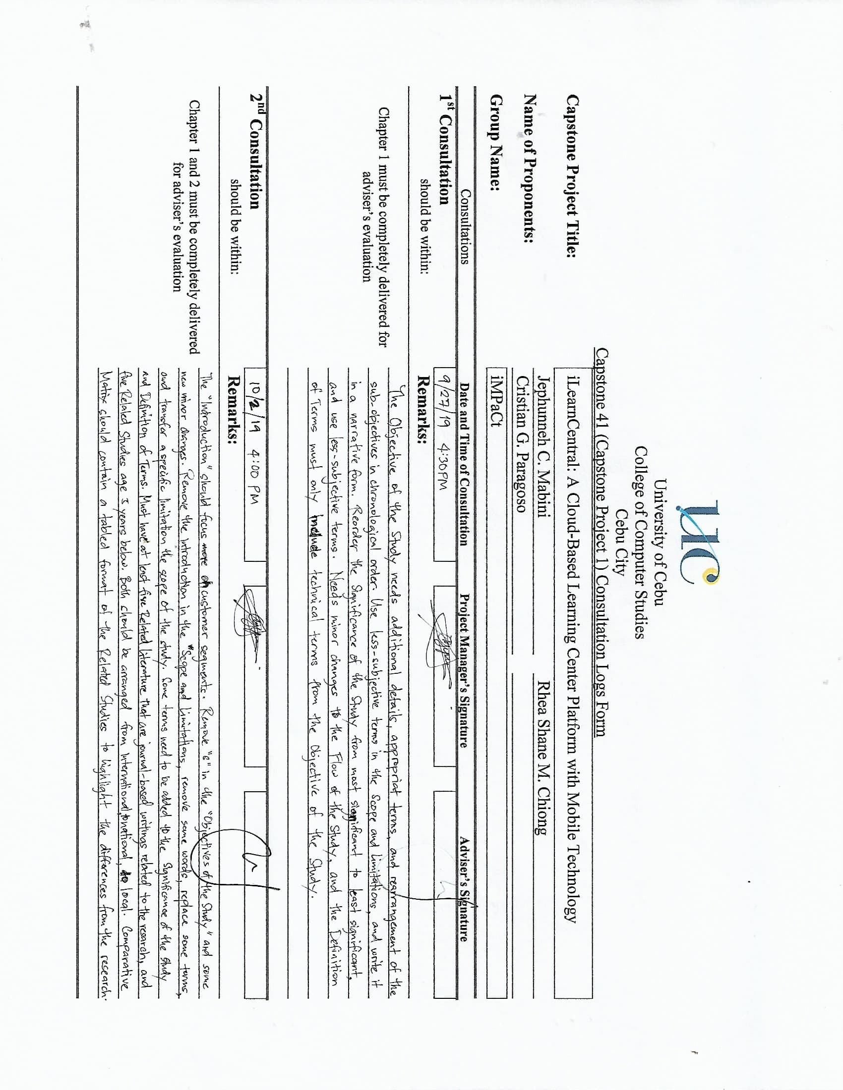

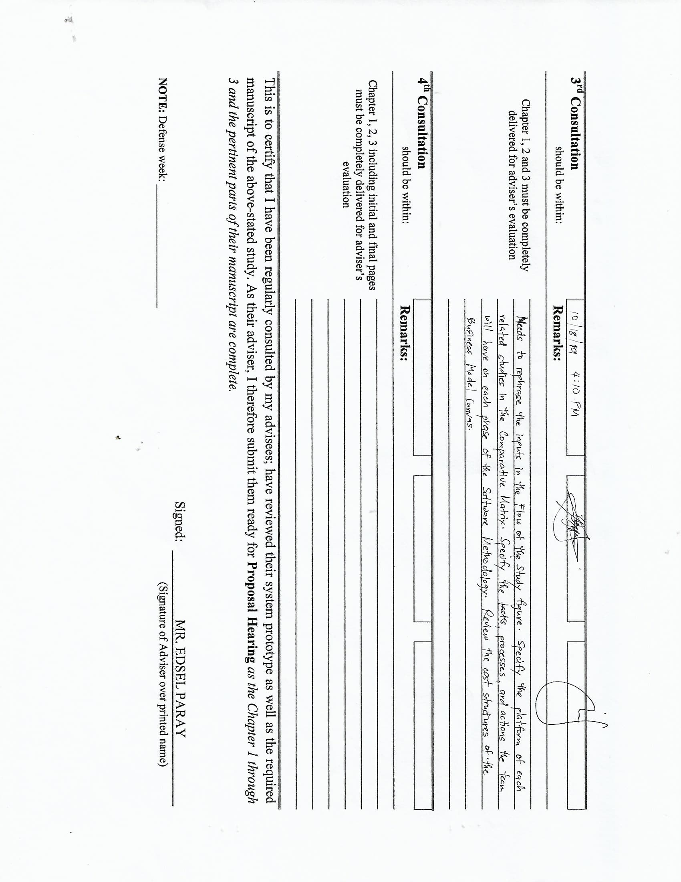

**Appendix C**

Censor’s Certificate

